IRMCO FLUIDS® 536 SERIES STAMPING LUBRICANTS:
IRMCO’s 536 series stamping lubricants were designed as heavy-duty, multi-purpose, oil-free alternatives to conventional, chlorinated paraffin-containing, emulsifiable-oil stamping fluids used in more sever/demanding applications. Products in this series have been used extensively in stamping automotive structural & emission control products, heavy industrial, cooking product & appliance components for decades.
IRMCO FLUIDS® 536 series product profile:
- Well suited for stamping conventional mild steels - up to 1.2 GPa tensile strength AHSS steels & stainless-steel applications.
- Easily mixed with water to form stable solutions using conventional chemical proportioning systems (HYDROBLEND, “venturi”-type & other mixing).
- Optimally applied via spray or roller application. Easily applied manually via swabbing, brushing, or wiping.
- Demonstrate excellent “weld-through” characteristics* over conventional oil-based stamping lubricants.
- Compatible with conventional, aqueous surface cleaning & pretreatment chemical regimes prior to powder paint, e-coat & porcelain enameling processes.
- Oil, nitrite, boron & triazine/formaldehyde-free chemistry.
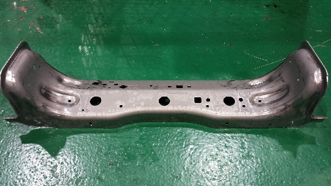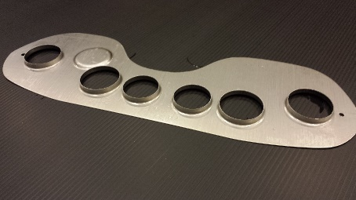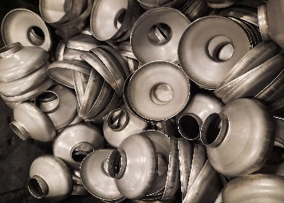
Statement about water quality impact on lubricant performance? Link?
Statement against recycling/reclaiming of lubricant solution? Link?
Disclaimer about “weld-through”? Link?
